Data Analyst Applicant Test Assignment

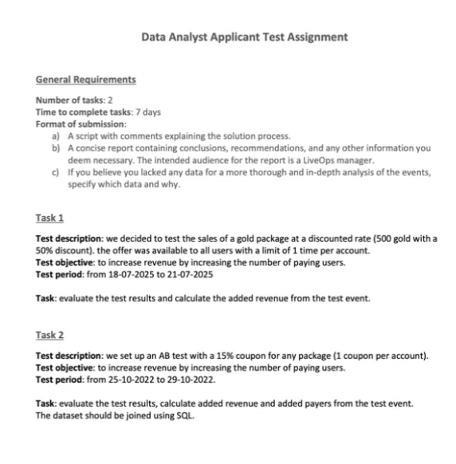

task 1 xlx
Test description: we decided to test the sales of a gold package at a discounted rate (500 gold with a
50% discount). the offer was available to all users with a limit of 1 time per account.
Test objective: to increase revenue by increasing the number of paying users.
Test period: from 18-07-2025 to 21-07-2025
Task: evaluate the test results and calculate the added revenue from the test event

task 2 xlx

Task 2
Test description: we set up an AB test with a 15% coupon for any package (1 coupon per account).
Test objective: to increase revenue by increasing the number of paying users.
Test period: from 25-10-2022 to 29-10-2022.
Task: evaluate the test results, calculate added revenue and added payers from the test event.
The dataset should be joined using SQL.

